*Laboratory work № 5*

*Tracking of a moving object which trajectory is disturbed by random acceleration*

*Eugenii Israelit, Dmitry Shadrin, Skoltech, 2016*

*Main goal*: To develop standard Kalman filter for tracking a moving object which trajectory is disturbed by random acceleration. To get deeper understanding of Kalman filter parameters and their role in estimation. To analyze the sensitivity of estimations on choosing of non-optimal parameters and in dependence on initial conditions.

*Steps 1-6:*

1. Generate a true trajectory $X_{i}$ of an object motion disturbed by normally distributed random acceleration

$$x_{i}=x_{i-1}+V_{i}T+\frac{a_{i}T^{2}}{2}$$

$$V_{i}=V_{i-1}+a_{i}T$$

Size of trajectory is 200 points.

Initial conditions: $x_{1}=5;V_{1}=1;T=1$

Variance of noise $a_{i}$, $σ_{a}^{2}={0.2}^{2}$

1. Measurements $z_{i}$ of the coo­rdinate $x_{i}$ were generated

$$z_{i}=x_{i}+η_{i}$$

$η_{i}$–normally distributed random noise with zero mathematical expectation   
and variance $σ_{η}^{2}={20}^{2}$.

1. The system at state space was presented. It was taken into account that only measurements of coordinate $x_{i}$ were available

$$X_{i}=ΦX_{i-1}+Ga_{i}$$

$$z_{i}= H_{i}X_{i} + η_{i}$$

Where $X_{i}$- state vector, that describes full state of the system (coordinate $x_{i}$ and velocity $V_{i}$);

$Φ$– transition matrix that relates $X_{i}$ and $X_{i-1}$;

$G$– input matrix, that determines how random acceleration $a_{i}$ affects state vector;

$z_{i}$– measurements of coordinate $x_{i}$

$H$**–** observation matrix

1. Kalman filter algorithm for estimating state vector $X_{i}$ was developed.

Initial conditions were used:

Initial filtered estimate $X_{0}=\left|\begin{matrix}2 \\ 0\end{matrix}\right|$

Initial filtration error covariance matrix

$$P_{0,0}=\left|\begin{matrix}10000 & 0 \\ 0 & 10000\end{matrix}\right|$$

1. Results including true trajectory, measurements, filtered estimates of state vector $X_{i}$.

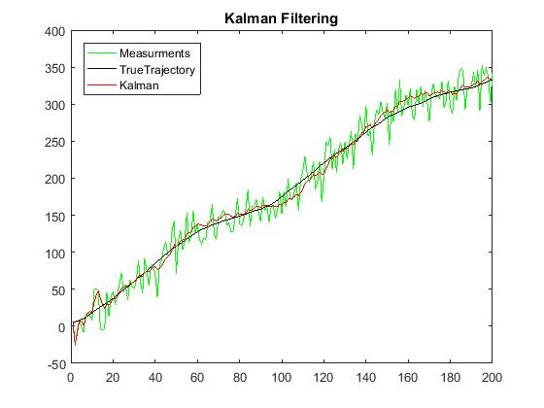

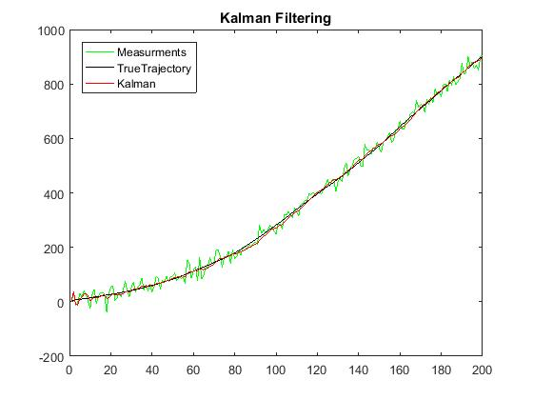After run of filter for several times. Estimation results were different with every new trajectory.

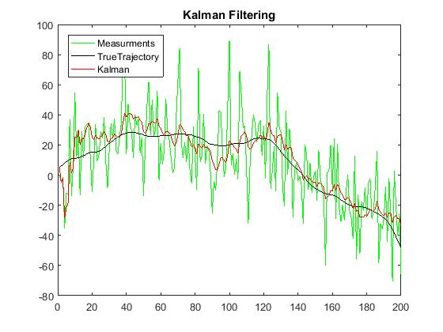

1. 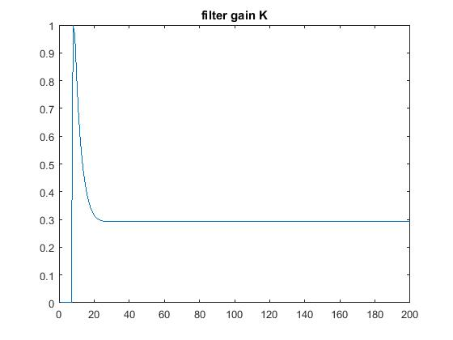Plot of filter gain $K$ over the whole filtration interval.

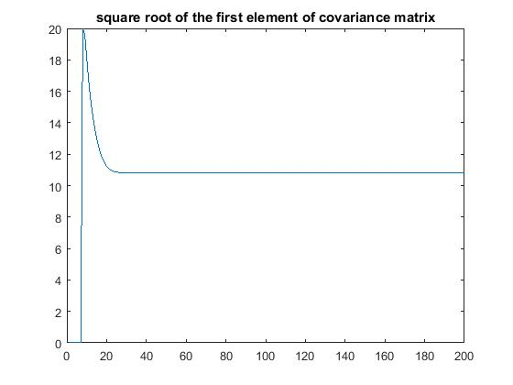Plot of square root of the first diagonal element of covariance matrix *Pii*

Filter gain $K$ and filtration error covariance matrix become constant very quickly. It means that in conditions of a trajectory disturbed by random noise we cannot estimate more than established limit of accuracy due to uncertainty.

1. The code extrapolation on $m=7$ steps ahead on every time step was done

$$X_{i+m-1,i}=Φ_{i+m-1,i}X_{i,i}$$

where

$$Φ_{i+m-1,i}=Φ_{i+m-1,i+m-2}Φ_{i+m-2,i+m-3}⋯Φ_{i+2,i+1}Φ_{i+1,i}$$

$$X_{7,1}=Φ_{7,1}X_{1,1}$$

$$Φ_{7,1}=Φ_{7,6}Φ_{6,5}Φ_{5,4}Φ_{4,3}Φ_{3,2}Φ_{2,1}$$

1. $M=500$ runs of filter was made. Dynamics of mean-squared error of estimation over observation interval was estimated. This error was calculated for filtered estimate of coordinate $x_{i,i}$ and its forecasting (extrapolation) $m$ steps ahead $x_{i+m-1,i}$.

Plot of the final error. When it becomes almost constant and estimation accuracy doesn’t increase anymore filter becomes stationary.

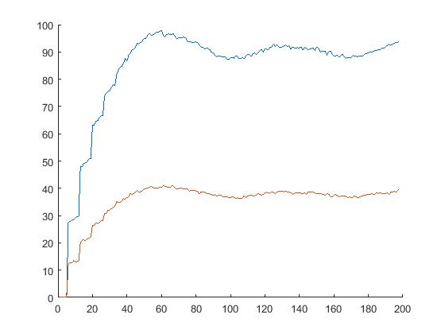

1. Plot for comparison mean-squared error of filtered estimate of coordinate $x_{i,i}$ with standard deviation of measurement errors.

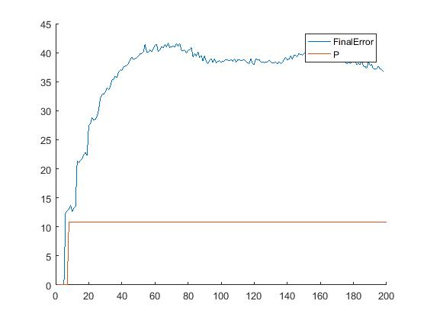

1. $M=500$ runs was made, but with more accurate initial filtration error covariance matrix

$$P_{0,0}=\left|\begin{matrix}100 & 0 \\ 0 & 100\end{matrix}\right|$$

Mean-squared error of filtered estimate of coordinate $x_{i,i}$ was calculated.

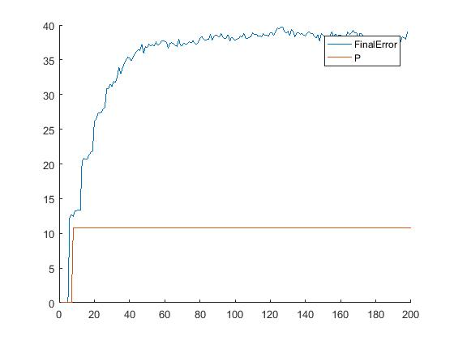

The accuracy of initial conditions $P_{0,0}$ doesn’t affect the estimation results. The choice of initial conditions doesn’t affect the estimation results when filter is not stable.

filter for deterministic trajectory (no random disturbance). It can be easily done by indicating in the code that variance of state noise equals to zero $σ_{a}^{2}=0$.

$M=500$ runs

1. 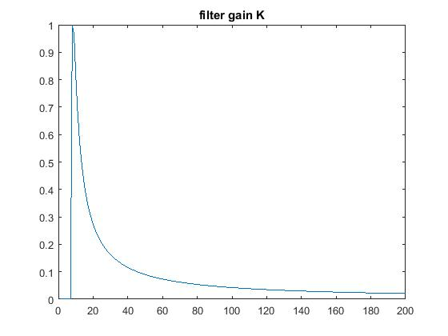Filter gain approaches to zero
2. 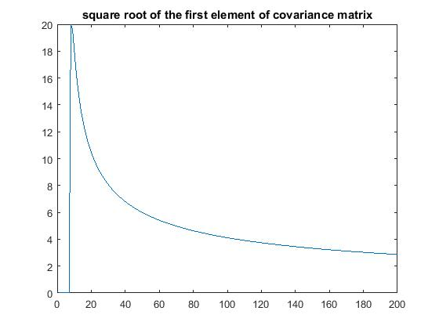Both true estimation errors defined according to item 8 and calculation errors $P_{i,i}$ (square root of the first diagonal element of $P_{i,i}$ that corresponds to standard deviation of estimation error of coordinate $x_{i}$) also approach to zero.

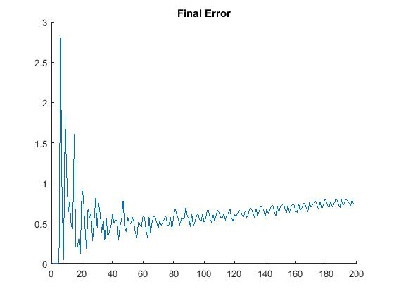

1. Use of deterministic model of motion, but motion is disturbed by random acceleration.

$M=500$ runs of filter estimate dynamics of mean-squared error of estimation over observation interval. P Calculation of this error provided for both filtered estimate of coordinate $x_{i,i}$ and its forecasting (extrapolation) $m$ steps ahead $x_{i+m-1,i}$.

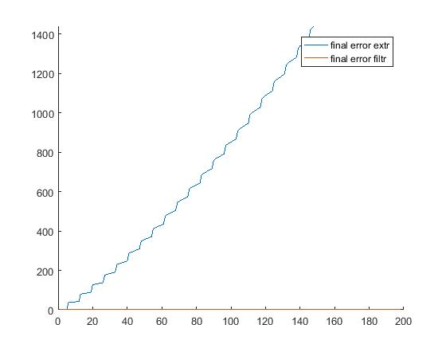

1. 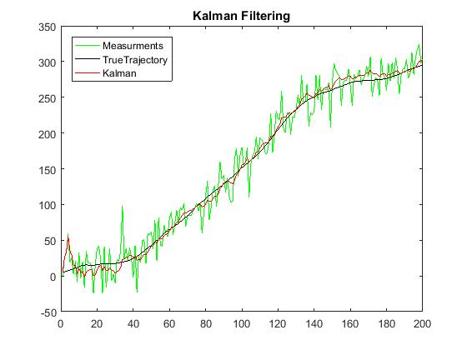The trajectory with variance of state noise $σ_{a}^{2}=1$ was generated. Below is comparison of estimation results with the trajectory where $σ_{a}^{2}={0.2}^{2}$.

